WORSHIP TIMES
Sunday School 8:45AM
Sunday Morning Worship 10AM
Sunday Evening 6PM
Wednesday Prayer Meeting and DU Classes 6PM
3270 Lantana Road, Crossville, TN 38572
Office: (93l) 788-2844 Fax: (931)788-5663
Web site: www.lrbc.church
E-mail: lrbc@lrbc.church

NEWS and CALENDAR EVENTS
Issue 8 Volume 2019
“I am come that they might have life, and that they might have it more abundantly.” John 10:10b

The Lifeless Classroom
At the end of the school year in May, I found myself looking around a silent classroom empty of any life. As my eyes glanced around the room, I noticed the desks where pens had scratched across paper; the Chromebooks on which numerous essays were typed; and the student work which had been so proudly hung on the walls. As always on the last day of school, I remembered how it was not the carefully placed decorations or the variety of supplies that brought life to the classroom; it was the students who brought the smiles and laughs, the eye rolls, and even the tears. All the pieces of the classroom worked together to provide the necessary activities for the students to learn. Yet it was the students, not the materials, that made the classroom breathe with life.
This year, as I made my usual mental circle around the classroom, a new insight occurred to me. Just as the students brought life to an empty, albeit prepared, classroom, Jesus Christ brings life to our empty hearts. No matter how much care is placed into preparing my classroom at the beginning of the school year, none of it matters without any students to do the learning. Likewise, regardless of the amount of time spent going to church, reading spiritual books, or doing good deeds in the name of Jesus, none of it matters unless Jesus Christ is the Lord of our hearts. Though these pieces do not give salvation, when the pieces of church, books, and deeds are combined with the presence of Christ in our hearts, only then can we experience the fullness of life. My teaching is worthless if I am trying to educate a lifeless classroom without students breathing the life into it. In the same way, no matter how much we try to get through life on our own, it is pointless without Christ breathing abundant life in our hearts. If we have already received that abundant life, we need to share it with the rest of the world, so that, like lifeless classrooms, lifeless hearts are filled with the love and joy that only comes from Jesus Christ.

AUGUST
SUNDAY | MONDAY | TUESDAY | WEDNESDAY | THURSDAY | FRIDAY | SATURDAY
 |  |  |  | 1  GA's Christmas in August  Prison Ministry | 2  6P-10P  YOUTH  Back2School  Bash | 3
4 | 5  Prison Ministry | 6  9AM  Prayer Group | 7  6PM  Prayer Mtg. &  DU Classes  7PM  Deacon Meeting | 8  11:30AM  SAM’s Luncheon  7PM  Bread of Life  (Midpoint)  Prison Ministry | 9 | 10  11AM  R*E*A*L  Luncheon
11  2PM  Nursing Home  6PM  Project 6:23 Banquet | 12  Prison Ministry | 13  9AM  Prayer Group | 14  6PM  6:23 Class #1  Prayer Mtg. &  DU Classes  7PM  Council Meeting | 15  Prison Ministry | 16 | 17  8AM  Men/Youth Boys Breakfast
18  4PM  Visitation #1 | 19  8:30AM  First Day of  Mother's Day Out  Prison Ministry | 20  9AM  Prayer Group | 21  4PM  Visitation #1  6PM  Prayer Mtg. &  DU Classes  6:23 Class #2  7PM  Stewardship Mtg. | 22  Prison Ministry | 23  Prison Ministry | 24  Youth Service  Project/event
25  4PM  Visitation #2  7PM  Communion | 26  Prison Ministry | 27  9AM  Prayer Group | 28  4PM  Visitation #2  6PM  Prayer Mtg. &  DU Classes  6:23 Class #3 | 29  Prison Ministry | 30

PROJECT 6:23
Faithful can be defined as loyal, constant, committed, unwavering, and steadfast. As followers of Jesus we have been given a task to complete. That task is the great commission. We are to go in to all the world and make disciples. Matthew 28:19-20. Why would Jesus give us such a task? 2 Peter 3:9 states “The Lord is longsuffering, not willing that any should perish, but that all would come to repentance.” How then shall they call on Him in whom they have not believed? And how shall they believe in Him of whom they have not heard? And how shall they hear without a preacher? Romans 10:14. A new semester of Project 6twenty3 will begin in August. This is your opportunity to take the gospel outside of the church and into our county. We have a class for learners where you will learn to use just one verse from the Bible to share the gospel. For the rest of us that have participated in Project 6twenty3 in the past can we make up our mind to remain faithful to the task of the great commission? If we say we love Jesus and we belong to Him then we should want to obey Him and carry on the work He left us here to do. We share in Romans 6twenty3 that salvation is free and this is true but discipleship will cost you something. Are you willing to give ONE hour a week to go and tell other people how they can have forgiveness and eternal life? What could be more important in our schedule than this? Someone took the time to invest in our lives and share the good news so let’s do our part for others. Therefore, my beloved brethren, be ye steadfast, unmovable, always abounding in the work of the Lord, forasmuch as ye know that your labour is not in vain in the Lord. 1 Corinthians 15:28.
Frank and Linda Lewis

Project 6twenty3

Project 6twenty3 starts soon! The first class will be August 14th. Visitation will start August 18th and August 21st. The banquet will be on August 11th at 6PM. Please bring a dessert and join us for some good food and great FELLOWSHIP!

MOTHER'S DAY OUT PROGRAM
Mondays & Wednesdays from 8:30AM-2PM, starting August 19th. Contact the
Church office for more information or
to pick up a registration packet.

Welcome
BY STATEMENT
Dan & Sherry Wentland

#CREW Corner
“And I thank Christ Jesus our Lord, who hath enabled me, for that he counted me faithful, putting me into the ministry;” 1 Timothy 1:12
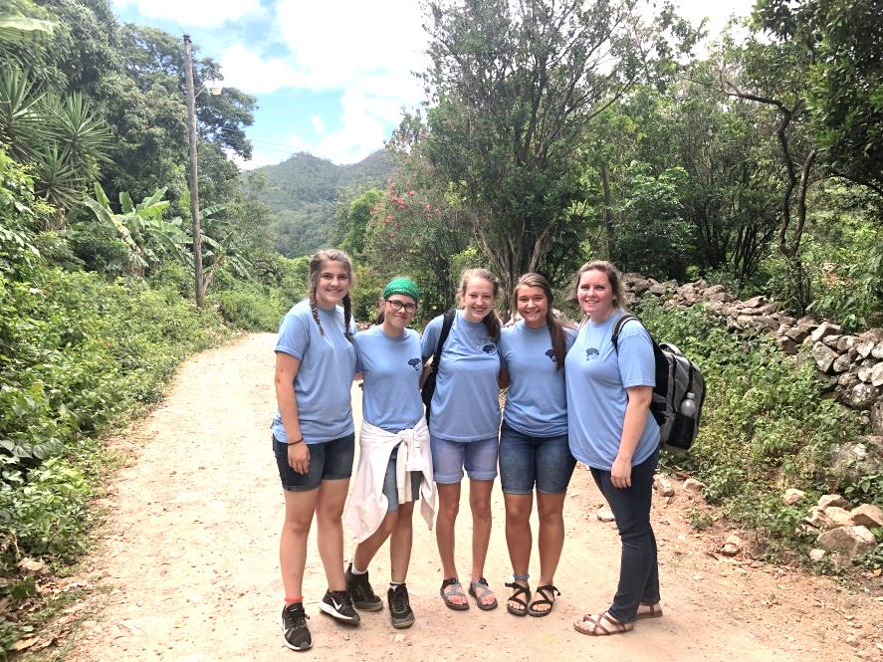
It has been an amazing summer in the youth group. God gave us some great opportunities to share His love with people and serve in His name. Even now, as I type this article, I am watching four of our #CREW ministering to the needs of the people in Honduras. It is incredible that God would allow us to serve Him at all, let alone call us to go into a foreign land and care for people’s bodies and souls. I can agree with King David when he wrote, “When I consider thy heavens, the work of thy fingers, The moon and the stars, which thou hast ordained; What is man, that thou art mindful of him? And the son of man, that thou visitest him?” (Psalm 8:3-4). Why on earth would God use us? We continually fall short and yet, He still allows us to serve him! Since He gives us this privilege, let’s take advantage of it and serve until He calls us home to Heaven. I am thankful to get to be a part of the Honduras Mission team and thankful to be serving alongside some of the greatest teens in Crossville; -the #CREW.

Youth Back to School Bash will be on Wednesday, August 2nd from 6PM-10PM for all incoming 7th graders to 2019 graduating seniors.

